1) Which response provides the strongest identification evidence?
A) “It is Liver because the line is green.”
B) “It is Liver Luo because it begins at LIV-5 and continues toward the genital region.” +++++
C) “It is probably Liver because it is on the leg.”
D) “It is Luo because the line is short.”
Feedback: The Liver Luo response names the system and supports it with both a Luo-point origin and a characteristic destination. Why are the other options incorrect? “It is Liver because the line is green.” — Color alone is unreliable and does not identify the system. “It is probably Liver because it is on the leg.” — Many channels travel on the leg, and the organ name alone is insufficient. “It is Luo because the line is short.” — A short line is not enough to prove a Luo origin or connection.
2) What is the correct order for analyzing an unfamiliar pathway image?
A) Name the organ, choose a color, count labels, guess.
B) Classify the system, locate the surface, trace the route, confirm a signature clue. +++++
C) Find one familiar region, ignore the rest, choose the closest name.
D) Identify a point number, assume Primary, stop.
Feedback: System classification, body-surface location, full-route tracing and signature confirmation provide a repeatable evidence-based sequence. Why are the other options incorrect? Name the organ, choose a color, count labels, guess. — Organ and color do not establish system identity. Find one familiar region, ignore the rest, choose the closest name. — One familiar region can be shared by several pathways. Identify a point number, assume Primary, stop. — A visible point number does not justify ignoring the rest of the route.
3) An image shows a little-finger origin, posterior arm, scapula and face/ear course. What is the strongest justified answer?
A) Small Intestine Primary Channel because the direction and two landmarks match. +++++
B) Heart Primary Channel because both reach the little finger.
C) Small Intestine Sinew Channel because every posterior line is Sinew.
D) Sanjiao Luo because it reaches the head.
Feedback: Little-finger origin together with posterior arm, scapular and face/ear landmarks supports the Small Intestine Primary route. Why are the other options incorrect? Heart Primary Channel because both reach the little finger. — Heart is Hand Yin and travels from chest to little finger rather than hand to head. Small Intestine Sinew Channel because every posterior line is Sinew. — A posterior line is not automatically Sinew; broad bindings would be required. Sanjiao Luo because it reaches the head. — Reaching the head alone does not identify a Sanjiao Luo route.
4) An image shows a broad superficial chain with several joint bindings and no deep zangfu entry. Which evidence statement is best?
A) It is Sinew because superficial spread and joint bindings define that system. +++++
B) It is Divergent because it has many branches.
C) It is Primary because it is long.
D) It is Luo because it crosses a joint.
Feedback: Broad superficial spread and multiple joint bindings are two independent features supporting a Sinew identification. Why are the other options incorrect? It is Divergent because it has many branches. — Branching alone does not establish deep Divergent organization. It is Primary because it is long. — Length alone does not establish a Primary route. It is Luo because it crosses a joint. — Crossing a joint does not prove Luo origin or connection.
5) An image shows a transverse band around the waist. Which justification is strongest?
A) Dai Mai because its overall geometry is transverse and girdles the waist. +++++
B) Yang Wei Mai because both include Yang in the name.
C) Gall Bladder Sinew because it is lateral.
D) Great Luo of the Spleen because it is broad.
Feedback: The transverse belt-like geometry and waist location together identify Dai Mai. Why are the other options incorrect? Yang Wei Mai because both include Yang in the name. — Yang Wei is longitudinal and links lateral Yang regions. Gall Bladder Sinew because it is lateral. — Gall Bladder Sinew follows a longitudinal lateral body chain. Great Luo of the Spleen because it is broad. — The Great Luo spreads across the lateral chest from SP-21.
6) What should be done when a likely answer is supported by only one landmark?
A) Confirm a second independent landmark or system feature before finalizing. +++++
B) Choose it immediately.
C) Use the line color as the second clue.
D) Ignore the terminal region.
Feedback: A second independent clue reduces errors caused by overlapping body regions and incomplete drawings. Why are the other options incorrect? Choose it immediately. — Immediate selection from one clue is vulnerable to look-alike routes. Use the line color as the second clue. — Color is not reliable independent evidence. Ignore the terminal region. — The terminal region may provide the needed confirmation.
7) How should a learner explain rejection of the closest distractor?
A) Name the missing or contradictory system feature. +++++
B) Say only that it looks wrong.
C) Refer only to option order.
D) Use the date of the image.
Feedback: Naming the missing or contradictory feature demonstrates why the alternative fails the same evidence test. Why are the other options incorrect? Say only that it looks wrong. — Appearance without evidence does not justify elimination. Refer only to option order. — Option order is unrelated to pathway anatomy. Use the date of the image. — Image date does not distinguish channel systems.
8) A source image omits an expected internal branch but matches the external course. What is the best conclusion?
A) Treat the identification as provisional and compare a complete reference. +++++
B) Conclude the branch does not exist.
C) Automatically reclassify it as Sinew.
D) Discard all other sources.
Feedback: A provisional identification followed by source comparison accounts for selective educational diagrams without inventing certainty. Why are the other options incorrect? Conclude the branch does not exist. — Omission in one image is not proof that a branch does not exist. Automatically reclassify it as Sinew. — Missing detail alone does not establish Sinew organization. Discard all other sources. — Source comparison is more appropriate than rejecting all other references.
9) What is the channel shown in the image?
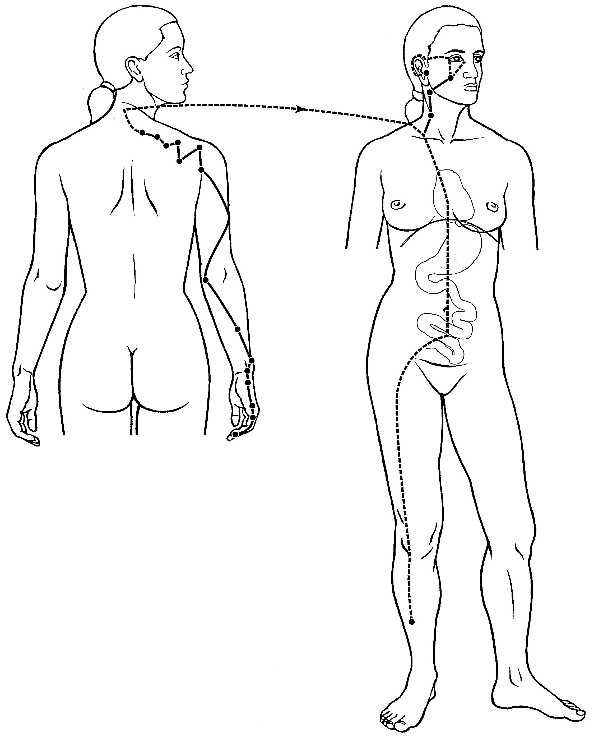
A) Small Intestine Primary Channel +++++
B) Small Intestine Sinew Channel
C) Small Intestine Divergent Channel
D) Small Intestine Luo-Connecting Channel
Feedback: The image is identified as the Small Intestine Primary Channel by its little-finger origin and posterior arm and scapular course toward the face and ear. Its internal branch enters the Heart, crosses the diaphragm, reaches the Stomach and belongs to the Small Intestine. Why are the other options incorrect? Small Intestine Sinew Channel — The Sinew Channel is broader and organized through superficial binding regions. Small Intestine Divergent Channel — The Divergent Channel is identified by deep entry and paired Heart convergence. Small Intestine Luo-Connecting Channel — The Luo-Connecting Channel begins at SI-7 and follows a shorter connecting course.
10) What is the channel shown in the image?
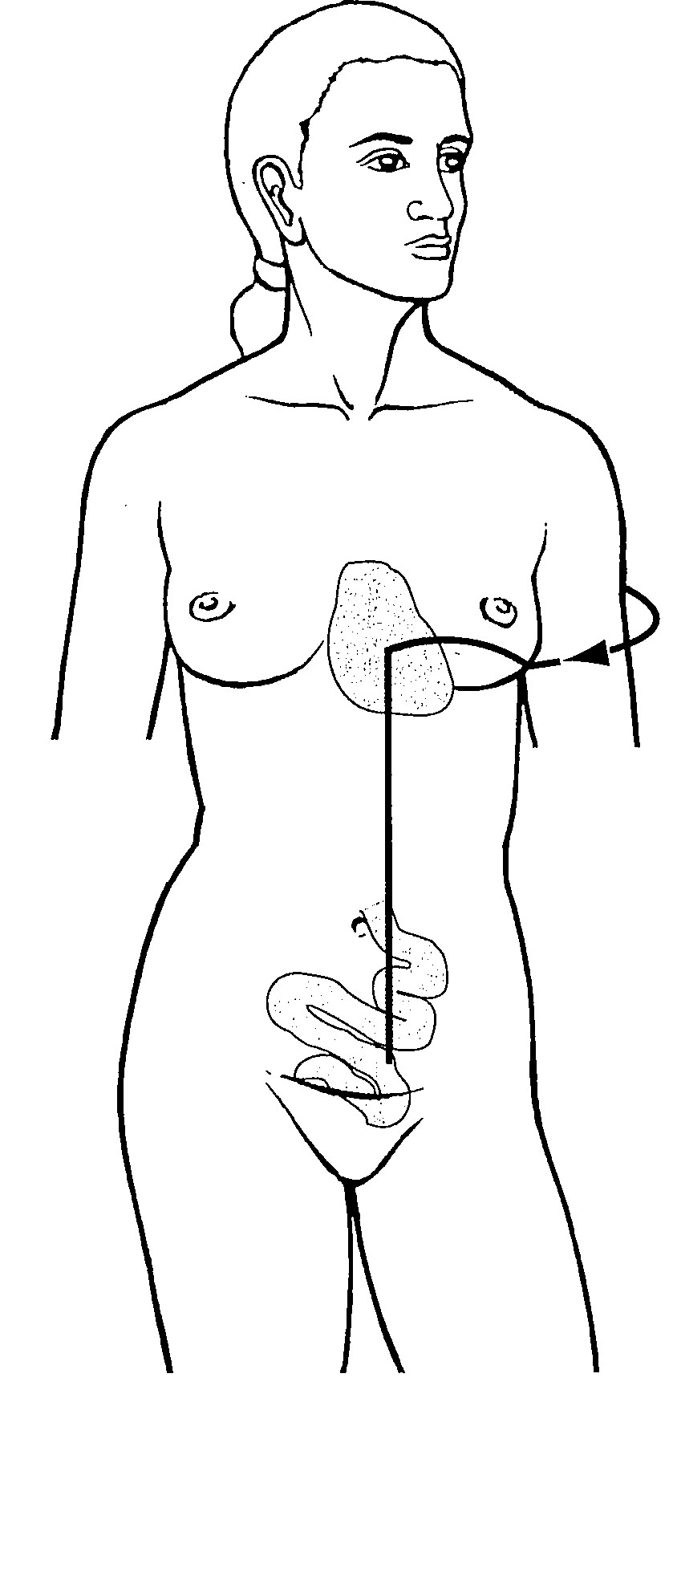
A) Small Intestine Primary Channel
B) Small Intestine Sinew Channel
C) Small Intestine Divergent Channel +++++
D) Small Intestine Luo-Connecting Channel
Feedback: The Small Intestine Divergent Channel separates near the shoulder, enters the axilla, crosses the Heart and descends through the diaphragm into the abdomen to connect with the Small Intestine. This deep internal route and paired Heart relationship distinguish it from the surface Primary, Sinew and Luo pathways. Why are the other options incorrect? Small Intestine Primary Channel — The Primary Channel is the external point-bearing route from the little finger toward the face and ear. Small Intestine Sinew Channel — The Sinew Channel is superficial and musculotendinous. Small Intestine Luo-Connecting Channel — The Luo-Connecting Channel begins at SI-7 and follows a limited connecting branch.

